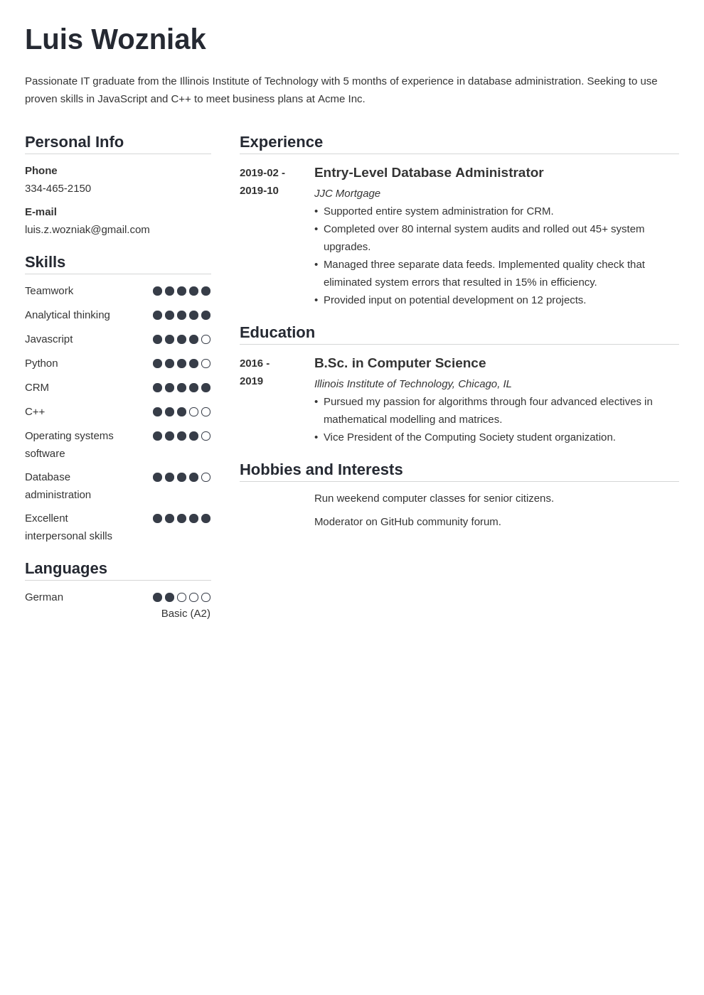
Luis Wozniak
Passionate IT graduate from the Illinois Institute of Technology with 5 months of experience in database administration. Seeking to use proven skills in JavaScript and C++ to meet business plans at Acme Inc.
Personal Info
Phone
334-465-2150
E-mail
luis.z.wozniak@gmail.com
Skills
Teamwork
Analytical thinking
Javascript
Python
CRM
C++
Operating systems
software
Database
administration
Excellent
interpersonal skills
Languages
Experience
2019-02-
2019-10
Education
2016- 2019
Entry-Level Database Administrator JJC Mortgage
• Supported entire system administration for CRM.
• Completed over 80 internal system audits and rolled out 45+ system upgrades.
• Managed three separate data feeds. Implemented quality check that eliminated system errors that resulted in 15% in efficiency.
• Provided input on potential development on 12 projects.
B.Sc. in Computer Science
Illinois Institute of Technology, Chicago, IL
• Pursued my passion for algorithms through four advanced electives in mathematical modelling and matrices.
• Vice President of the Computing Society student organization.
Hobbies and Interests
Run weekend computer classes for senior citizens.
Moderator on GitHub community forum.
German
Basic (A2)

